Seventy-Seven
I like the magic of the number seven,
better yet -- the mythical seventy-seven.
Wonders of the world were seven,
Christian works of mercy order seven.
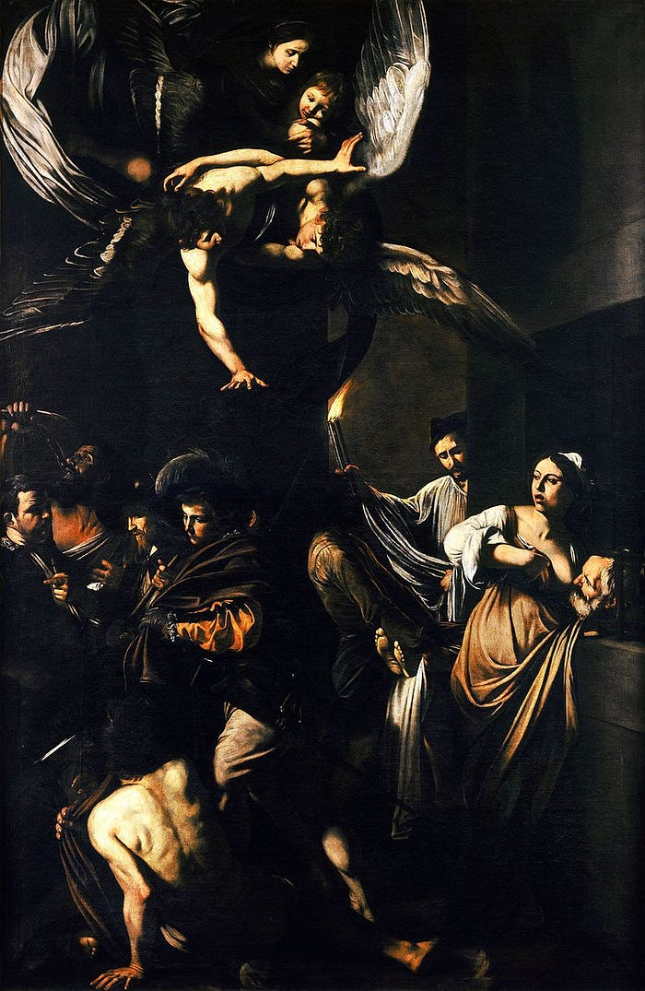
Caravaggio, the Seven Works of Mercy
at the church of Pio Monte della Miseriocordia in Napels
We learned the seven Christian virtues: Charity,
faith, hope, prudence, justice, temperance, humility,
and heard of seven deadly sins: Arrogance, debauchery
greed, wrath, sloth, envy, gluttony.
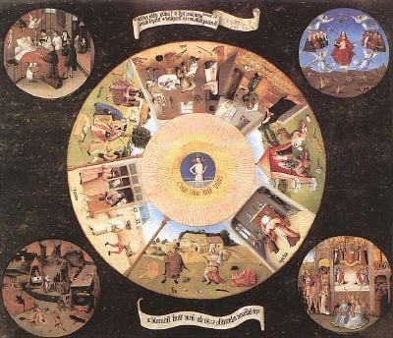
Hieronymus Bosch, the Seven Deadly Sins, Museo del Prado, Madrid
Rainbow colours seven under heaven:
Red, orange, yellow, green
blue, indigo and violet seen.
The days of every week still tally seven.
Myriad stars illuminate the firmament -- most nights.
We relish looking for the seven Great Bear super lights:
Alkaid, Mizar, Alioth, Megrez, Phecda , Dubhe, Merak merrily.
The constellation Ursa Major was already known to Ptolemy.
The Himalayan trek invites to seven pristine lakes,
where seasoned hikers can redeem some city heartaches.
Florida invites to drive its sunny Seven-Mile bridge
to secluded beaches and escape the tricksy seven year itch.
Seven are the hills of Rome: the Palatine, Capitoline,
Aventine, Caelian, Quirinal, Viminal, and Esquiline.
Ionian Heptanese islands also seven: Kerkyra
Paxi, Lefkada, Ithaki, Kefalonia, Zakynthos and Kythira.
Biblical as well its transcendental aura:
Seven are the arms of the Menorah,
seven years took Solomon to build
the hallowed Temple, blessings-filled.
Terpsichorean was the cure for Herod’s woeful ails:
Young Salome performed a dance of seven veils.
Today sopranos reenact the ancient mysteries
to rapturous, spell-binding Straussian melodies.
When Simon Peter asks how many times
we should forgive each other, Jesus rhymes
“seventy times seven”. Thus forgive
to be forgiven, learn to love and live!
Equidem, I honour seven standards: honesty
toward myself and others, generosity, integrity,
proportionality, compassion, equanimity and gratitude.
But living up to them demands some fortitude!
“Homo sum. Humani nil a me alienum puto”. Comedy
and tragedy relate the sinusoidal tale of all humanity.
Record it, heeding seven C’s: chronology, causality,
cui bono,context, compass, change and commonality.
Dum spiro spero. Good to breathe and feel alive,
still blessed with prospects, awe and drive!
I never dreamt of such longevity,.
accept the vital bonus gratefully!

Content that even now at seven-seventy --
I have not lost my animus scribendi,
osculum semper aestimavi vitae,
nunquam taedium vitae!
Yes, felix sorta mea contentus,
Life is such a marvel, every day a plus!
God knows when I will have to take the leap,
like Frost I think there’re “miles to go before I sleep”.
Non sum, qualis eram, smile upon this time and space,
content that tempora mutantur, nos et mutamur in illis.
Change enriched my life, and for my resting place:
gaudeamus, laudamus -- urbi et orbi in optimis illis !

https://www.worldhistory.org/The_Seven_Wonders/
https://www.usccb.org/beliefs-and-teachings/how-we-teach/new-evangelization/jubilee-of-mercy/the-spiritual-works-of-mercy
https://www.christianity.com/wiki/christian-terms/what-are-the-seven-heavenly-virtues.html
https://www.newworldencyclopedia.org/entry/Seven_Deadly_Sins
Genesis 9 :8-15.
Iconic 1955 movie with Marilyn Monroe.
1 Kings 6, https://www.biblegateway.com/passage/?search=1%20Kings%206&version=GW
Richard Strauss, Opera Salome, Opus 54, first performed in December 1905 at the Semper Opera in Dresden. https://www.dailymotion.com/video/x72clm9
Matthew 18: 21-22.
As far as I am concerned.
Terentius, Heauton timorumenos 77. “I am human and regard nothing human as alien to me”
Cicero, Pro Milone, “who benefits?”
I always start my history lessons with these seven C’s.
As long as I breathe, I have hope. Original by Greek poet Theocritus (3rd century BC)
Desire to write.
The kiss of life I always cherished, never tired of life !
I am happy with my lot in life
Robert Frost, Stopping by woods in a snowy evening (1923). https://www.poetryfoundation.org/poems/42891/stopping-by-woods-on-a-snowy-evening
Horatius, Odes 4, 1,3 -- I am not as I used to be.
Ovidius, Metamorphoses 15, 165. Time changes and we change with the times.
We rejoice, we praise
To the city and the world in the best of circumstances.

